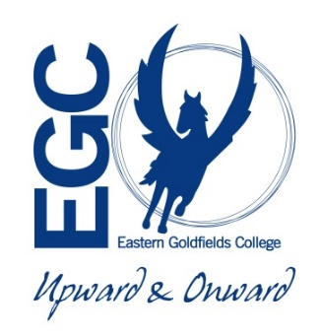**General Integrated Science Unit 3**

**Task : Mine Rehabilitation**

**Assessment Type : Extended Response**

**Weighting : 7.5%**

**Time allowed for the task:**

* 1 week to research the topic and complete your ***notes*** at school and home as far as possible.
* Field visit to KCGM to learn how KCGM rehabilitate the land after mining. Then one more day to complete notes before handing them in.

**How the mining industry carries out rehabilitation of land:**

The mining industry is the main contributor to the economy of Western Australia and Australia as a whole. However the environmental impact of mining the landscape is massive and its effect on the ecosystem is often unmeasurable. The government is trying to make companies accountable for their environmental footprint but often the cost or the feasibility is too much for anything substantial to be done.

KCGM is having a major impact on the environment of the goldfields both economically and environmentally. However due to their extensive rehabilitation program the company is taking measure to reduce their environmental footprint.

**Elements of the task:**

**Part A. Create a set of notes on the following questions using your own research and the information from the field trip. 50% of final mark**

1. How much money does Western Australia make from the mining industry approximately and how many people does it employ? *(1 mark)*
2. What are the main minerals mined for in Western Australia? *(2 marks)*
3. What are the main environmental issues that arise with large scale open pit mining such as the Super Pit? *(3 marks)*
4. What is KCGM’s environmental responsibility to **all** groups within the community during mining **and** after the pit closes? *(7 marks)*
5. Information and data is needed to make decisions about how rehabilitation needs to be done. Where does this information come from? *(2 marks)*
6. What is a waste rock dump and how are they used at KCGM? *(3 marks)*
7. What factors have to be considered when creating a design for the waste dump? *(3 marks)*
8. What kinds of tests are carried out to collect the information needed to build the waste dump and then rehabilitate it? *(4 marks)*
9. Once the waste dump has been created, what are the next steps to be carried out to start the rehabilitation of the land? *(4 marks)*
10. Once the final steps have been complete, why is constant monitoring of the waste dump carried out?

*(2 marks)*

1. Have all the rehabilitation projects undertaken at KCGM been successful? Give an example.

*(2 marks)*

1. Why is the waste rock not put back where it came from? *(1 mark)*

**Part B. Field Trip (34 marks) 50% of final mark**

* These will be handed in the next lesson after the field trip.

|  |  |
| --- | --- |
| **Requirements for assessment** | **Due dates** |
| * Your draft research notes completed at home | **30th May** |
| * Your completed research notes and Super Pit tour booklet | **3rd June** |

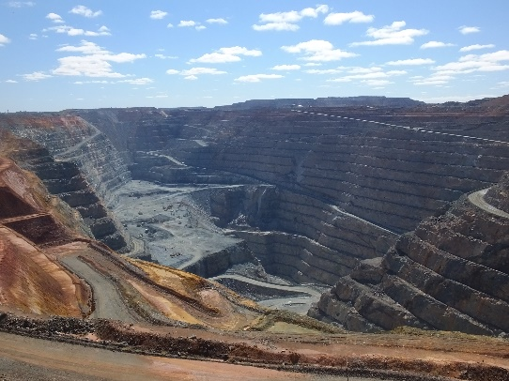During the field trip you will stop at various spots that will show you different aspects of rehabilitation being carried out by KCGM or that have been carried out.

The rules governing rehabilitation are continually changing and what was deemed correct 5-10 years ago may now not correct anymore. With the advances in technology more information has been gained about the environment and this has also lead to changes in the thinking about how rehabilitation should be done.

**Stop 1**

**Superpit lookout – oxide dump and construction of waste rock dump**

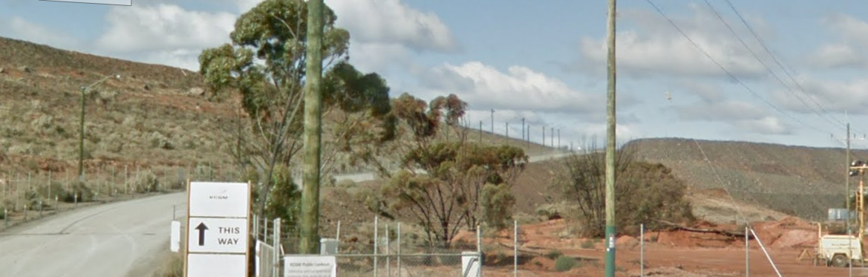

1. How deep is the pit currently?

600 – 700m (1)

1. Can the pit be dug any deeper?

Yes, but you have to start from the top, dig top wider and then come down before can made deeper (1) *Yes with a reason*

1. Can the pit be filled in once mining has finished?

No, not economically viable, cost too much/impossible to move all the dirt back in safely

*No with reason (1)*

1. How do the workers know where to blast and where to dig?

Geologists survey the site first and work out where the gold is (1)

Figure out best way to get it out which will determine where to start digging (1)

1. 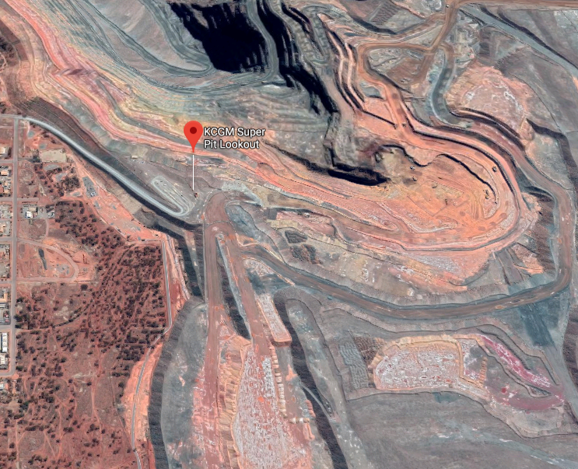Why are the dump trucks coming from the Morrison starter pit taking different routes when they are full of rock?

Depends on what they are carrying (1), waste rock goes to waste rock dump (1), rock that has a little ore in goes to storage dump (1), if it contains ore goes to processing plant/mill (1)

1. What is the difference between oxide and waste rock?

Oxide contains lots of salt (1)

Found in the layer above the waste rock (1)

Oxide erodes quicker (1)

1. Why does material like oxide have to be covered with so much waste rock?

To stop the salt coming to the surface and killing plants (1)

To stop it eroding when it rains (1)

1. When the oxide has been covered with waste rock what is the next step in rehabilitation?

The top soil has to be put on (1)

Top soil is then dug into the rock/ripping (1)

1. When does seeding take place?

Once the soil has settled/straight away (1)

1. How is it done and why do they do it?

Seed is spread by hand/walk up and down and scatter/(can have seed box on back of ripper)

Hand is better as ripping seed get buried and doesn’t germinate (1)

**Stop 2**

**Great Eastern Highway- Croesus Noise Bund Corner successful rehabilitation**

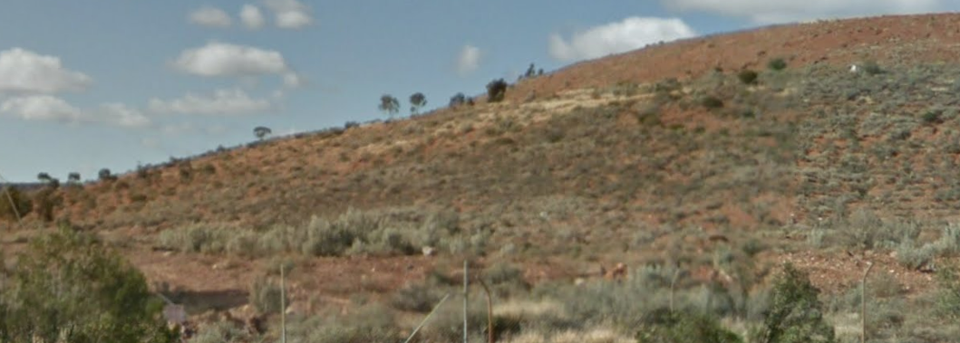

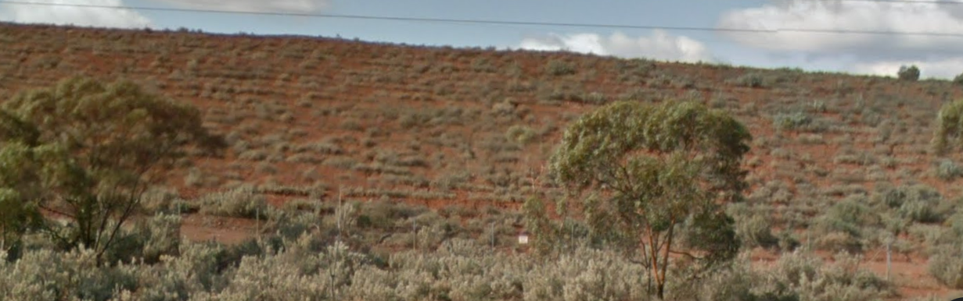

1. What is the point of the waste rock dump along the edge of the Great Eastern Highway?

Acts as a noise barrier – stops noise from pit reaching town (1)

1. Why is it unusual to get such good vegetation growth on this shaped waste dump pile?

The side of the waste dump faces the afternoon sun (1)

It gets really hot in afternoon which usually stops plants growing (well) (1)

1. In this kind of environment how long does it take for plants grow to a significant height (to see if the rehabilitation is working?

Something may grow after two – three years

Significant height maybe 8-10 years

**Stop 3**

**Boorara Road- Croesus Noise Bund, oldest rehabilitation**

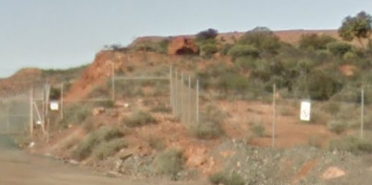

1. State the difference between this style of rehabilitation and the ones down Black Road and Bulong Road.

Lots of top soil was put on top (1)

Black road ripped top soil into rock so doesn’t erode as quick (1)

1. Why have they changed the way things are done?

Top soil is being eroded very quickly if on top (1)

When mixed in doesn’t erode so much so plants better chance (1)

Put in rock band at 50m mark to slow water running down slope to stop erosion (1)

1. Why are material properties important when deciding how to dump waste rock initially before rehabilitation?

Different sizes and types erode differently(1)

Alter speed at which water runs down – need right angle to stop erosion (1)

Soil type varies – trying to put “flat soil” on a slope need a way to hold it there (1)

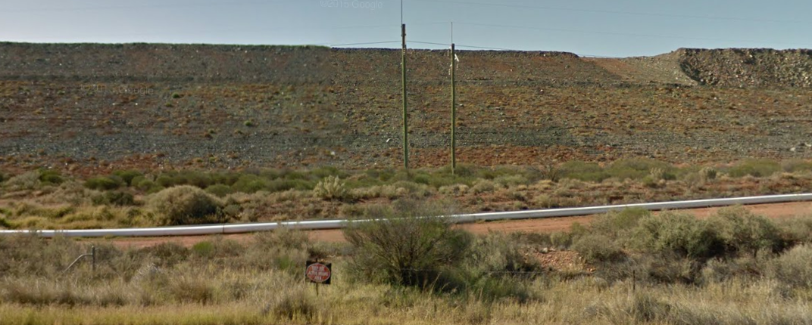**Stop 4 Black Street – Northern Rehabilitation**

1. When was this site rehabilitated?

2013 (1)

1. How was the rehabilitation carried out?

Waste rock dumped 37o (1)

Dozers flatten to 17o (1)

Top soil ripped into the surface (1)

Seeds scattered by hand (1)

1. Where did the rock come from that made the pile?

Inside the pit

1. Where did the soil come from that the plants are growing in?

Is the original soil that was there before mining (1)

Soil was removed and stored until needed to be put back in place (1)

1. Why is the success of the rehabilitation difficult to establish?

Because the plants take so long to grow (1)

Due to lack of rain (1)

1. What was learnt from this rehabilitation and how were things changed?

Rock band slowed the water reducing erosion (1)

Mixing soil in successful so keep doing that (1)

Things were kept the same (1)

**Stop 5**

**Black Street/Bulong Road – Northern Dump Rehabilitation**

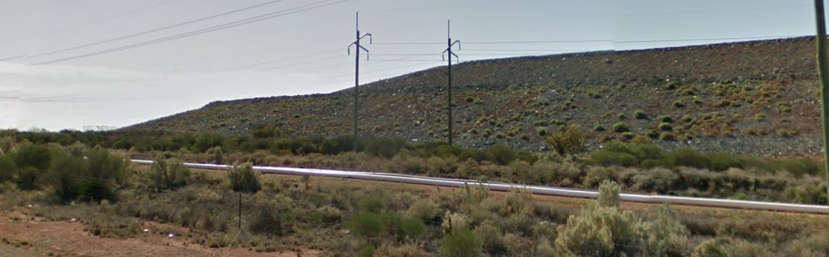

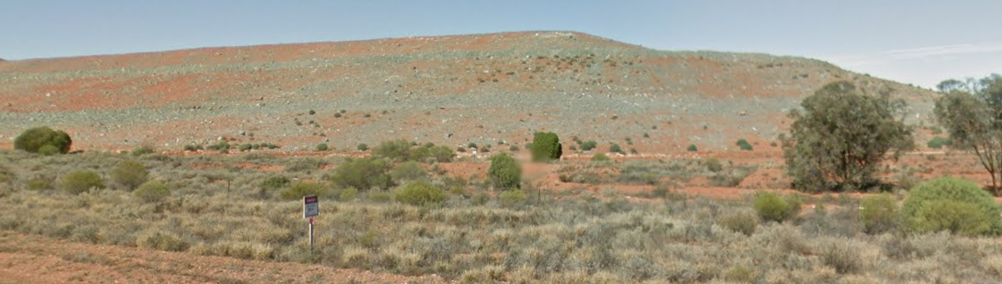

1. When was this waste rock dump rehabilitated?

2015 (1)

1. How can you tell if it has been more successful than the previous one?

By how much plant growth is there (1)

How much erosion has taken place (1)

1. What things have been changed and have they worked?

Changed nothing as it was working (1)

Seems to be working but only done 3-4 years ago so difficult to tell (1)

**Stop 6**

**Bulong Road – Tailings Dam Trial Rehabilitation**

1. Why has only a small amount of ground been rehabilitated?

Test patch to see which method works the best (1)

If find the best method will save money in the long run (1)

1. What tests are being carried and why are they being done?

Trying different depths of rock 1m 0.5m (1)

To find which supports most growth/erodes the least (1)

1. Is this normal practise? Why are the tests carried out?

Yes when looking for more efficient way to do things/when trying something new (1)

Expensive to do whole lot and then find it didn’t work so have to redo it (1)

**Stop 7**

**Bulong Road – waste rock dump prior to levelling/changing angle**

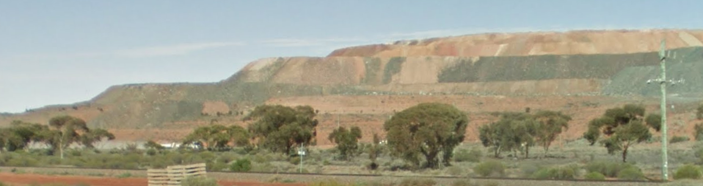

1. What angle is the waste rock dumped at?

37o (1)

1. What information determines how much rock can be dumped and at what angle? Max 3 marks

The type of rock in the waste (1)

The dump truck method of dumping (1)

How much room you have to dump the rock (1)

Restrictions from the airport (1)

1. Is the pile all waste rock?

Oxide underneath covered in waste rock (1)

1. Why is the angle of the waste rock changed when it is going to be rehabilitated?

The dozers cannot go on a slope at 37o (1)

Animals cannot walk on slope if too steep so cannot be rehabilitated (1)

If too steep erosion will occur quickly washing material down to bottom (1)

**Stop 8**

**Bulong Road – tailing dump**

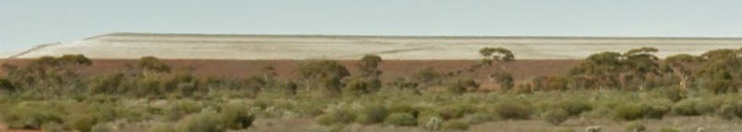

1. What is a tailings dam? How is it different to a waste rock dump?

Ground up rock and water – (1)

left over rock after ore has been removed (1)

waste dump is rock with no gold/rock that is not processed (1)

1. Why is there water in the tailings dam and what happens to it?

As rock settles the water collects in the middle (1)

The water is pumped out and used again in the mine (1)